The EGGER Group is taking a big step in climate protection and commits to Net Zero 2050
With its climate-friendly products, the family company would like to contribute towards protecting and preserving the future.
The EGGER Group is taking a pioneering step in terms of climate protection. The wood-based material manufacturer commits to the Net Zero target by 2050. On its way to reaching this goal, EGGER is setting itself ambitious climate targets and developing comprehensive measures to drastically reduce climate-impacting greenhouse gas emissions throughout its value chain.
Active climate protection as a major duty
EGGER manufactures products from the raw material that is central to active climate protection: wood. Wood binds CO₂ – a significant advantage that also comes into play in wood-based materials. In the last financial year 2022/2023 alone, EGGER products stored 6.4 million tonnes of CO₂. The family company has always attached great importance to the effective and sustainable manufacture of its products. Already today, 70% of the energy used comes from renewable sources. However, EGGER does not see these measures as the end of its own responsibility for climate protection and is therefore now taking a big step further.
“As a wood-based material manufacturer, our business model has always been linked to environmental and climate protection. We therefore see it as our duty to reduce our climate-impacting emissions. In this way, we want to ensure that we can also enable future generations to live and work sustainably with our climate-friendly wood-based materials“, says Thomas Leissing, CFO & Speaker of the Group Management.
This self-perception gives rise to an explicit ambition to make a significant contribution towards protecting and preserving the future. EGGER has established an ambitious, forward-looking climate strategy to reduce the Group-wide carbon footprint.
Commitment to Net Zero by 2050
EGGER is committed to reducing its climate-impacting greenhouse gas emissions in line with the Paris Climate Agreement. EGGER is committed to the Net Zero target by 2050.
The Net Zero target means that emissions must be removed from the atmosphere at the same rate as they are produced. EGGER has developed a comprehensive Group-wide approach to steadily reduce its climate-impacting emissions to Net Zero by 2050. The family company is explicitly focussing on reduction, not on compensation outside its own value chain.

Transparent analysis as starting point
The basis of any targeted climate strategy is the transparent, verified and regular accounting and disclosure of climate-impacting greenhouse gas emissions in all three scopes. The corporate carbon footprint for the EGGER Group in the climate target base year 2022 is as follows: The direct emissions of the EGGER plants (Scope 1) only account for 10% of the carbon footprint. Indirect emissions from purchased energy (Scope 2) account for 14%. And finally, 76%, i.e. the vast majority, are generated as indirect emissions in the upstream and downstream value chain (Scope 3).
A step-by-step approach with far-reaching investments
It will be challenging to make the Net Zero 2050 target a reality. EGGER has determined milestones along the way. By 2030, the family company has set the following interim targets: By 2030, the direct emissions from its own plants (Scope 1) will be reduced by at least 30%, the indirect emissions from purchased energy (Scope 2) will be reduced by at least 40% and the indirect upstream and downstream emissions (Scope 3) will be reduced by at least 10%. The details of the EGGER Group's climate strategy can be found at: to.egger.link/climate-strategy
Comprehensive measures in numerous areas of the company are on the strategic agenda. The wood-based material manufacturer will be making far-reaching investments. Additional biomass power plants and photovoltaic systems are planned in order to continue the decoupling from fossil fuels. EGGER will also promote the purchase of electricity from renewable sources and work closely with its business partners on new technical, technological and process-related solutions, for example with regard to the chemical raw materials used in the manufacture of products or with regard to transport.
EGGER has chosen a fact-based approach in defining its climate strategy and has analysed in detail how the set climate targets can be achieved. EGGER will continuously and transparently communicate the status of the achievement of its climate targets.

The EGGER Group commits to Net Zero by 2050

- EGGER has set itself the goal of contributing towards the protection and preservation of the future and commits to Net Zero by 2050.  - Along the way, EGGER is setting itself interim targets and pursuing comprehensive investment plans. | - The details of the climate strategy can be found at to.egger.link/climate-strategy  - The wood-based material manufacturer will regularly communicate transparently on the status of target achievement.

About EGGER
The family company, founded in 1961, is a leading international manufacturer of wood-based materials with more than 11,000 employees and 22 production locations worldwide. EGGER is a full-range supplier for furniture and interior design, for wood construction and for wood-based flooring, making it a reliable partner for the furniture industry, wood and flooring retailers and DIY stores. In the financial year 2022/2023, the EGGER Group generated a turnover of EUR 4.45 billion.
Being a sustainable business is always at the centre of EGGER's activities: 65% of the wood used already comes from recycling or by-products. At the end of their long life, EGGER products are in turn largely recyclable and can be reintroduced into the cycle. With this and many other measures, the family business is constantly working towards its goal of "creating more from the valuable resource wood" and thus enabling sustainable living and working.

Captions
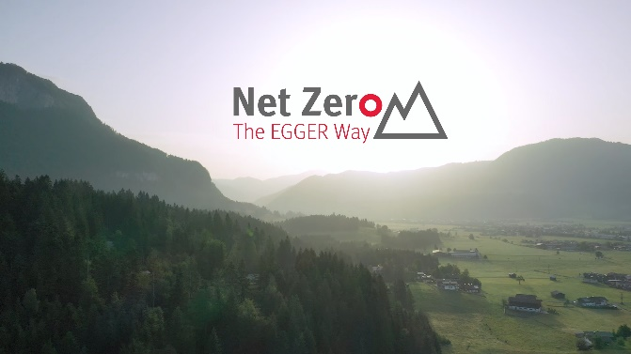 | The EGGER Group sees active climate protection as its great duty and commits to Net Zero by 2050.
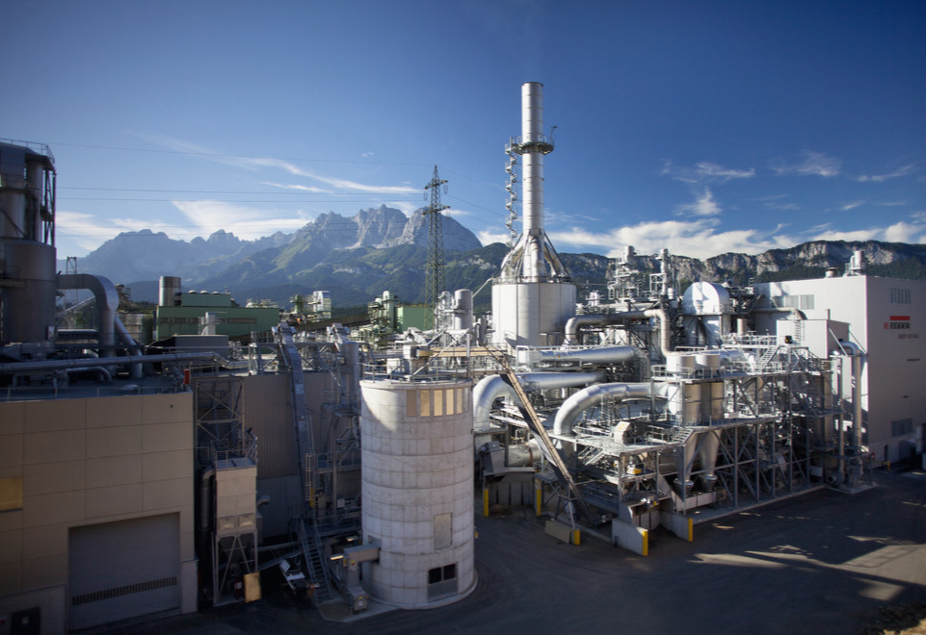 | Already today, 70% of the energy used comes from renewable sources. EGGER will further increase this share with extensive investments and at the same time reduce its own carbon footprint.

PHOTOS: EGGER Holzwerkstoffe, reprints naming the copyright owner are free of charge
IMAGE DOWNLOAD: https://celum.egger.com/pinaccess/showpin.do?pinCode=jubtuswjUYdI

For queries:
EGGER Holzwerkstoffe GmbH
Katharina Wieser
Weiberndorf 20
6380 St. Johann in Tirol
Austria
T +43 5 0600-10128
katharina.wieser@egger.com

